**(24) Ocean Temperature & Salinity**

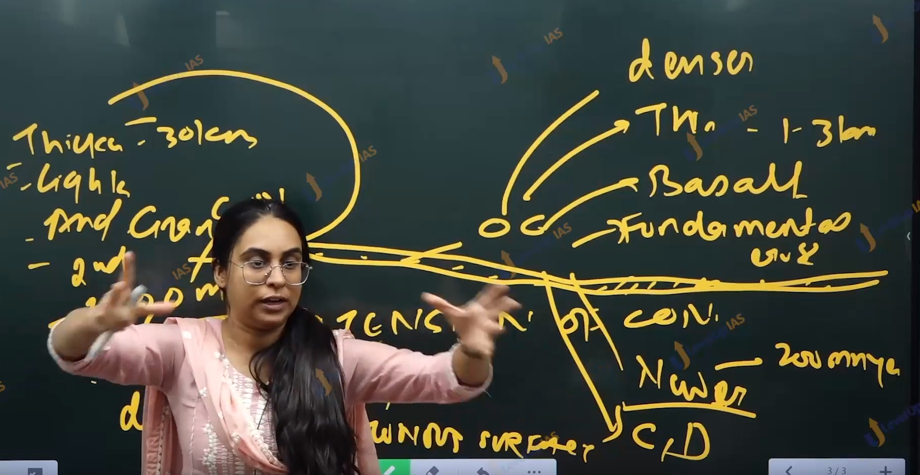



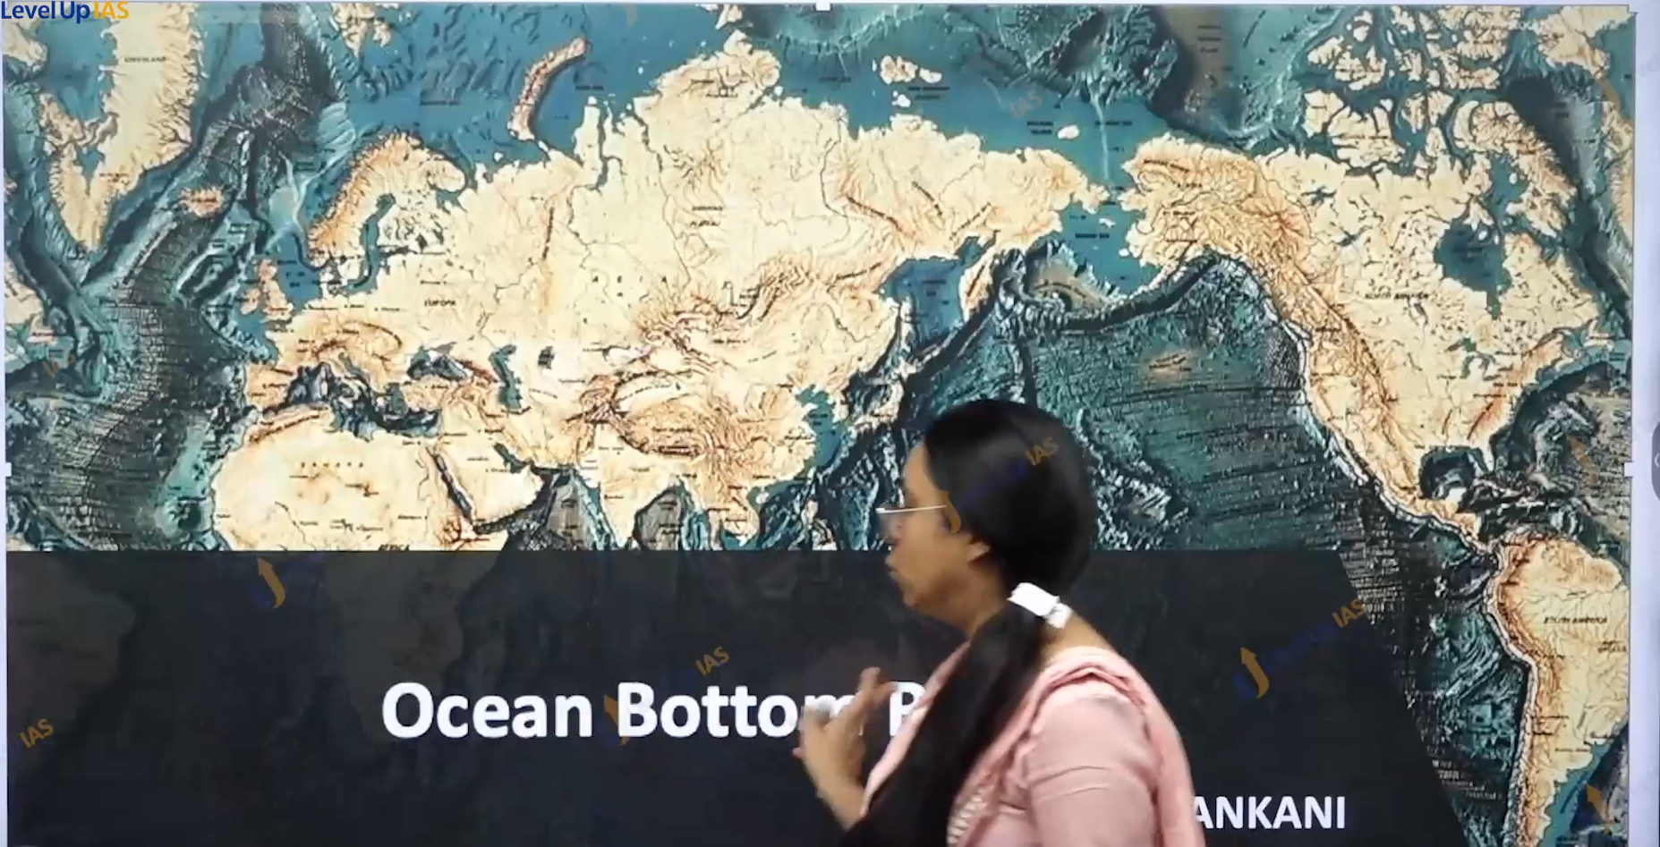

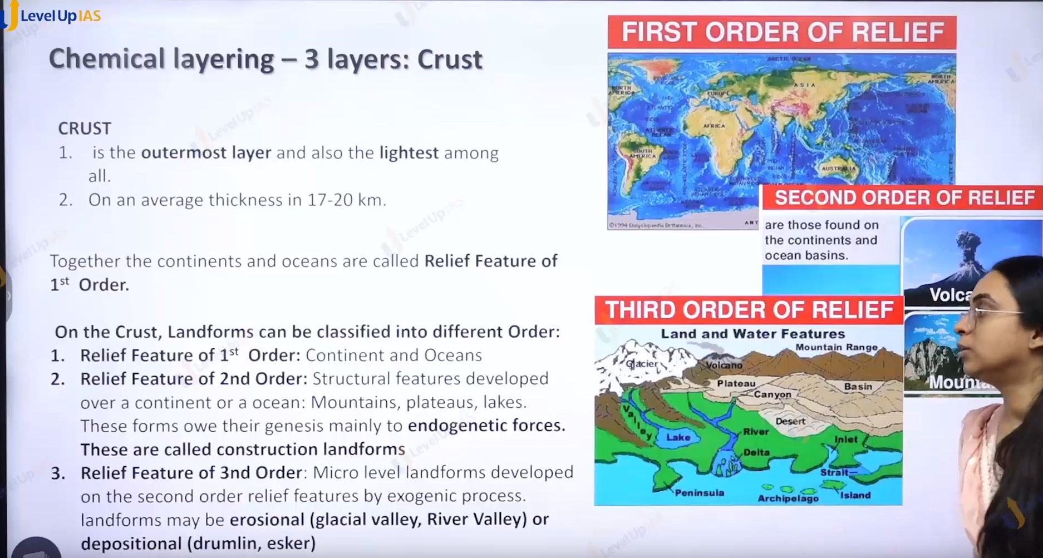

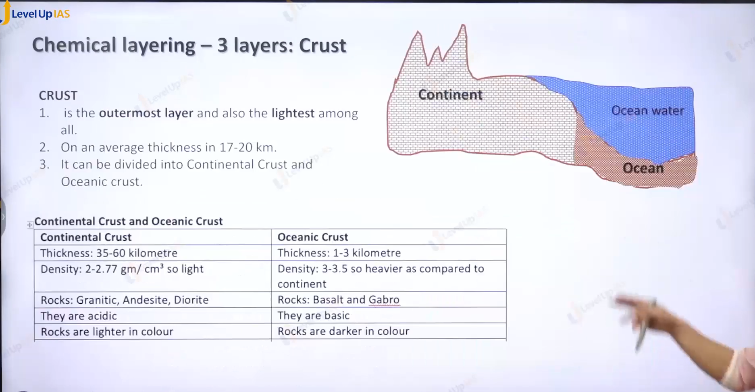

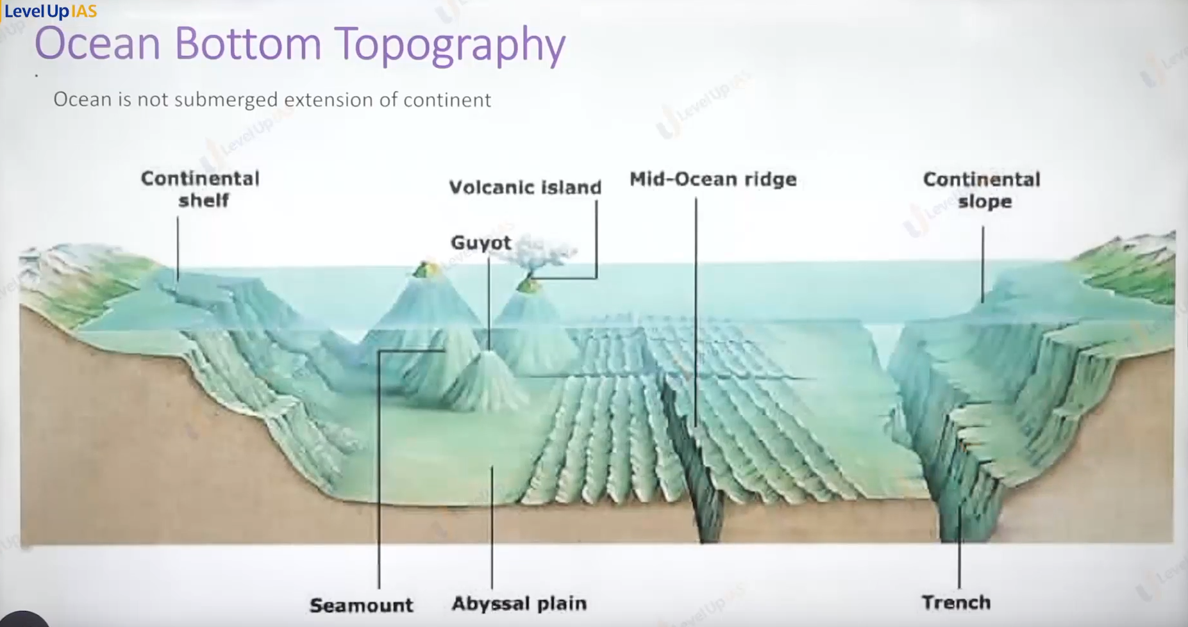

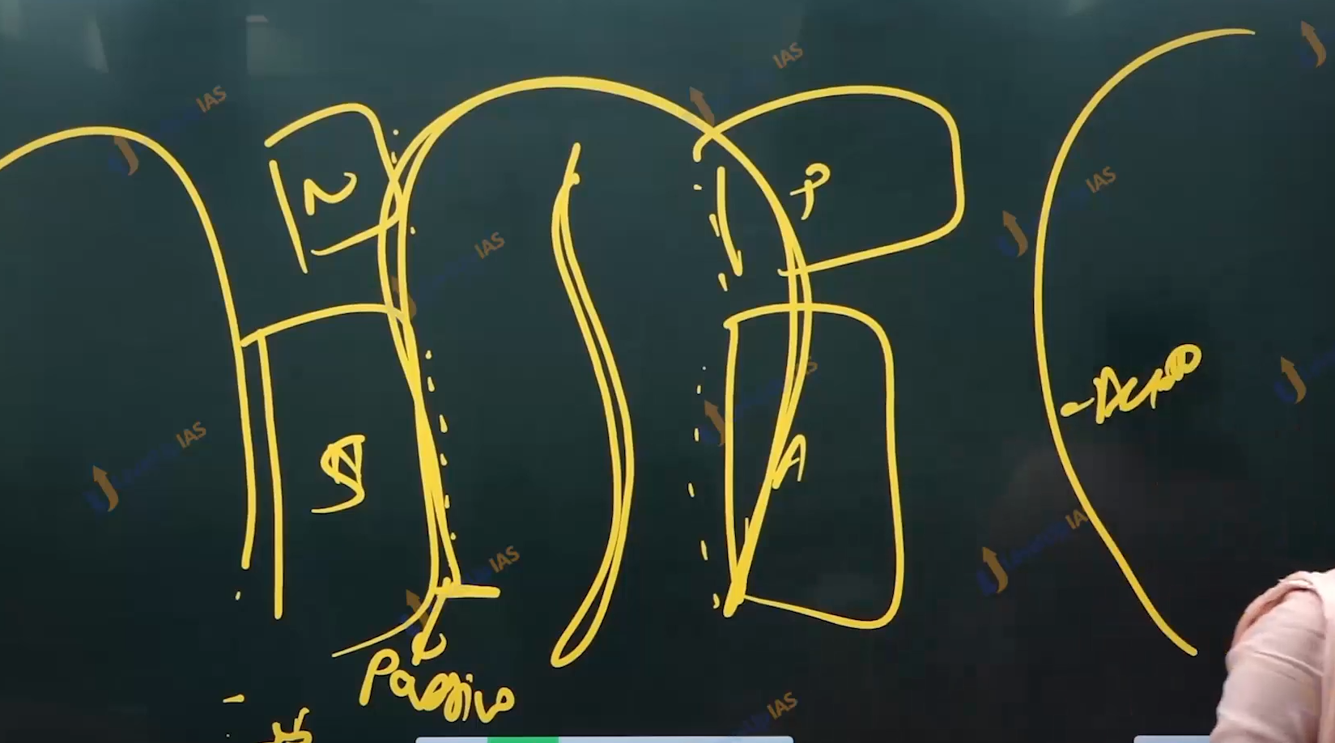

Ocean bottom Relief:

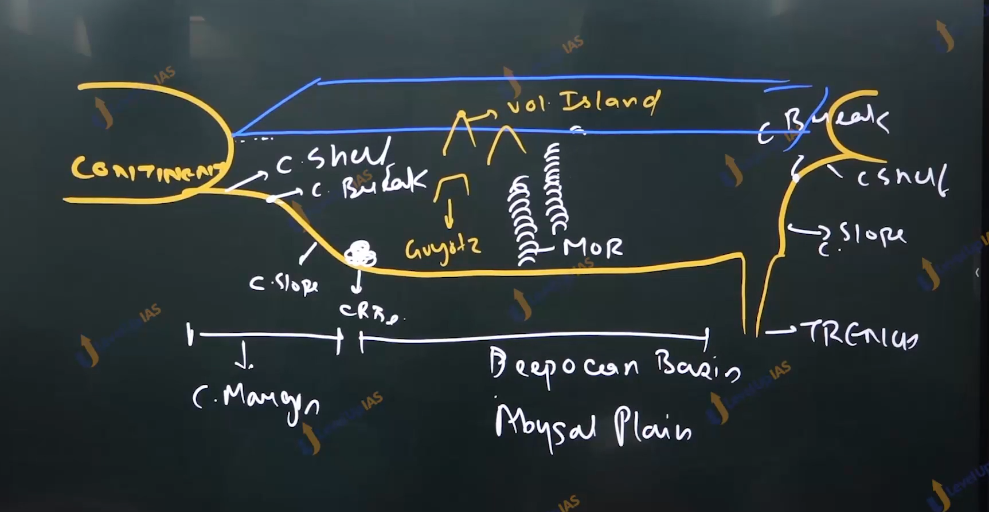

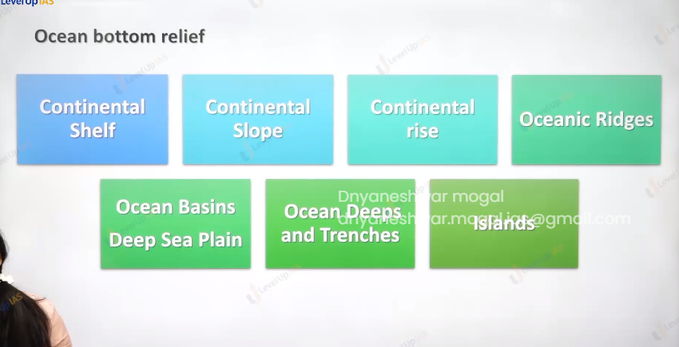

1. The ocean floor are rugged with the largest mount range, deepest trench and largest plane. On the ocean floor the feature has been by the tectonic process and volcanic process depositional process.
2. Deeper point of trench is ocean deep

Continental shelf:

1. It is a gently sloping extension of a continental plane.
2. The continental shelf of all the ocean together covers 7.5 % of the total area of ocean.
3. The depth of the continental shelf is 30 – 600 m. The average depth is 200m.
4. The gradient of the continental shelf is 1 degree or even less.
5. The end of continental shelf is called continental break. And the continental shelf is followed by a deep and steep slope.
6. The Continental shelf is covered by sediment brough by river and glacier.
7. Massive sedimentary deposits receive over the long time trap the marine organisms which eventually turns the source of fossil fuel.
8. The Continental shelf is mainly formed due to submergence of part of continent also because of sedimentary brought by river.
9. The average width is 80 km however continental shelf is almost absent or very narrow along the active margin ( where plate interaction is taking place) it extensive when it on passive margin.

Continental slope.

1. Continental slope is slope between outer edge of continental shelf and deep ocean floor.
2. It is cut by submarine canyons in many locations.
3. The gradient of slope can varies 2 – 5 degree as much 30 -60 degree.
4. The depth of continental slope 200 to 3500,3600 m. average depth of ocean floor is 4100 m.
5. Continental slope because of steepness have very little deposit along the base of continental slope there are deposits of sediments called as continental raise this is seen along the passive margin.
6. In the active margin rather the continental rise there is trench.

Submarine canyon:

1. Submarine canyon are deep valleys inside the ocean water. They cut across the continental shell and continental slope.
2. They are founded by turbidity current (sediments falling off in the ocean water.) falling of from the continental shelf.

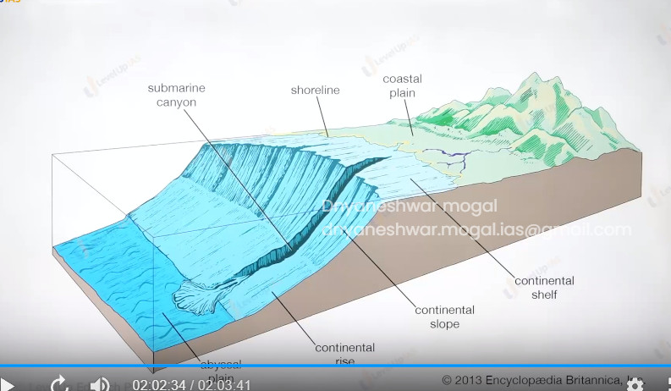

Abyssal plain/ deep ocean basin:

1. They are flattest surface in the ocean floor they are formed because of sediments eroded from the land and the deposit of ocean deposits.
2. Depth 3000 – 4000m . deep ocean basin have extensive mountain chain (mid-oceanic ridge MOR), Oceanic islands, guyot,

(images of Ocean bottom topography)

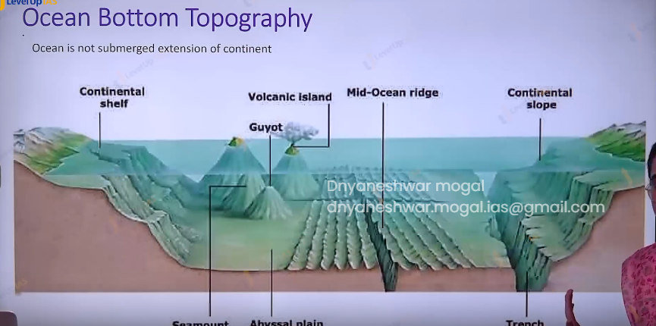

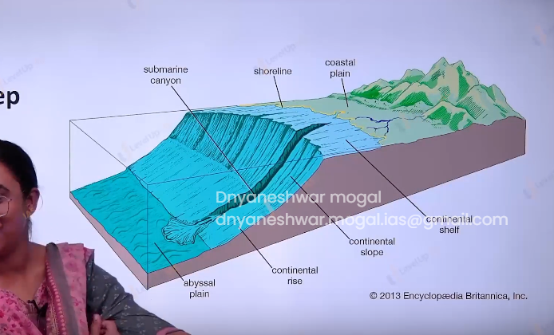

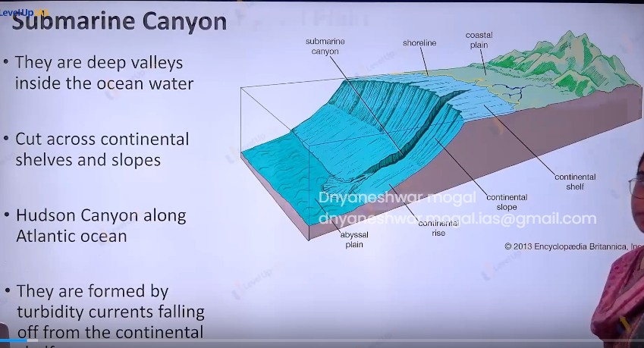

Mid-Oceanic ridge

1. MOR is found on the divergent plate boundary. It is composed of chain of mountains.
2. The mountain ranges can have the peek up to 2500 km but sometime the peak can reach up to ocean surface. Ex island,

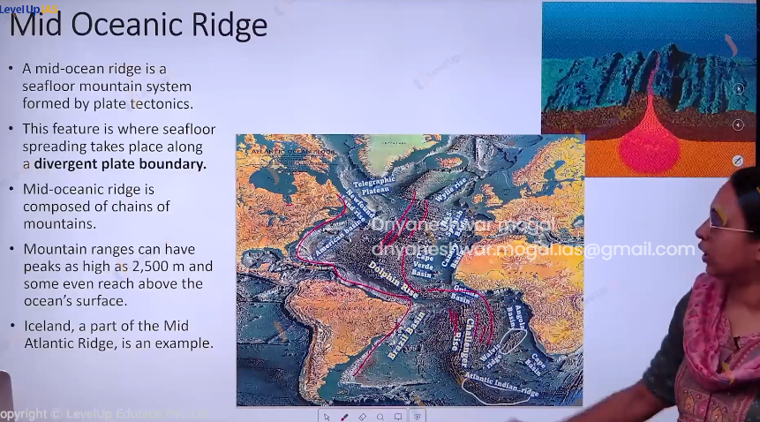

(images of Mid Oceanic Ridge)

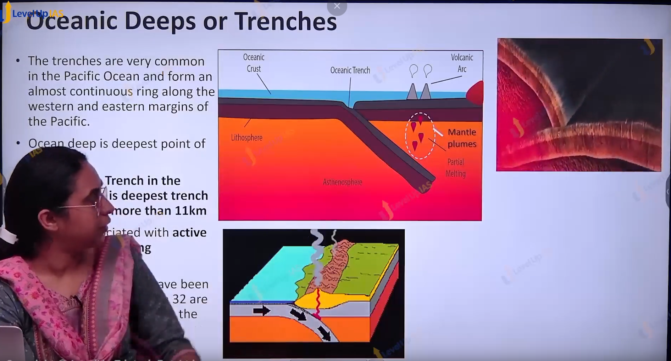

Trenches and the ocean deeps.

1. Trenches are relatively steep and narrow gaps on the ocean floor.
2. Trenches can be 3-5 km deeper than the surrounding ocean floor. (they are some of deepest part of ocean)
3. Trenches are formed due to ocean-ocean convergent and subduction or Ocean-continental convergent and subduction.
4. Ex: marina, Philippine, common along the Pacific Ocean.
5. Trenches are very common in the Pacific Ocean ex.
   1. Aleutian trench
   2. Kuril trench
   3. Japan trench
   4. Izu Bonin trench
   5. Mariana’s trench
   6. Bougainville trench
   7. Tonga trench
6. Mariana trench is deepest trench with depth more than 11 km.
7. Ocean deep is deepest point of trench ex. Challenger deep.

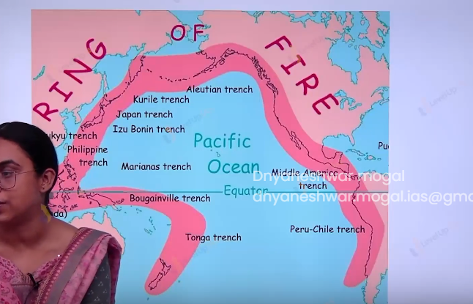

( ring of fire images)

(image at 25:30)

Seamount, Volcanic Island and Guyotz:

1. They are generally formed due to hot spot activity. Volcanic island can reach up to surface, where are sea mount does not reach the surface.
2. Sea mount has a pointed summit (top).
3. Sea mount is formed because of volcanic activity and can be as tall as 3000 m. ex emperor sea mount.

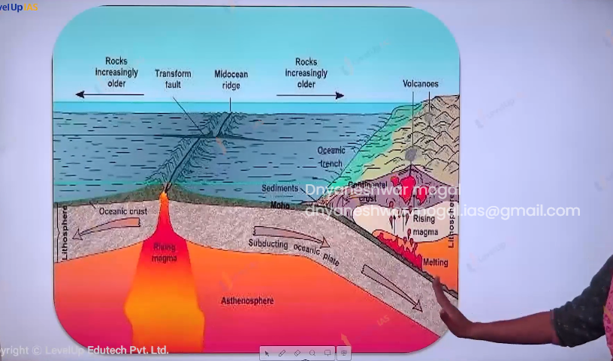

(image at 26:52)

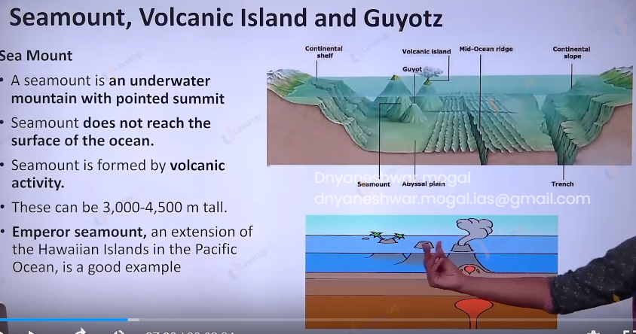

Guyots:

(images at 30:39)

1. Guyots are table mounts. it is flat top sea mount.
2. It shows gradual subsidence due to erosion and therefore it flat top.

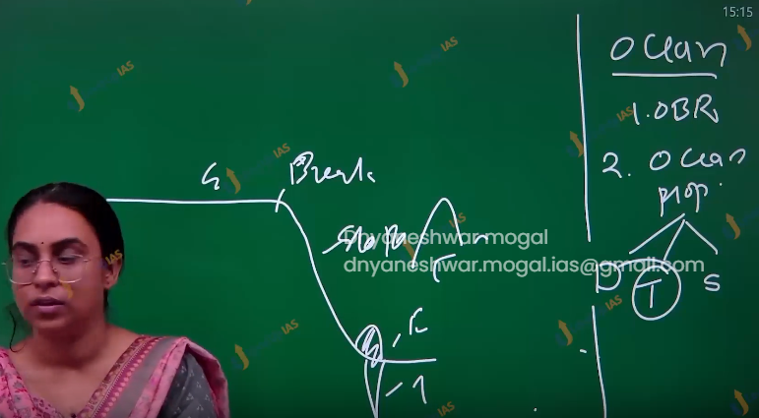

(images at the 34:12)

(images at 35:40)

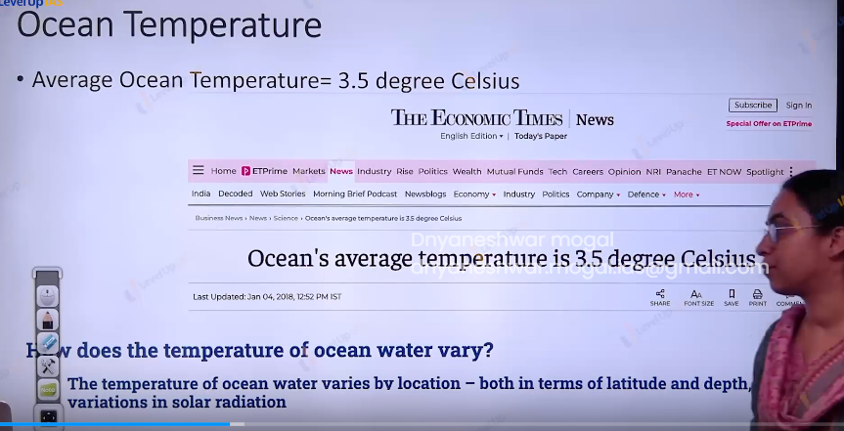35:49

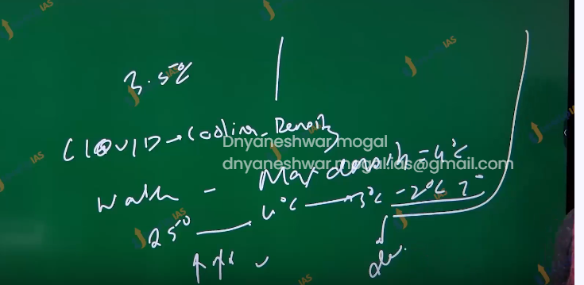

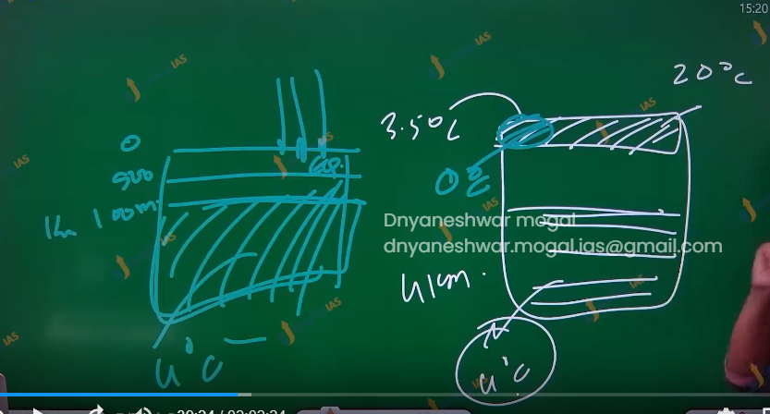

Ocean Temperature:

1. The average ocean temperature is about 3.5 degrees Celsius, however the temperature vary by the location both w.r.t latitude and depth. Due to variation in the solar radiations.

Factor affecting the Ocean temperature:

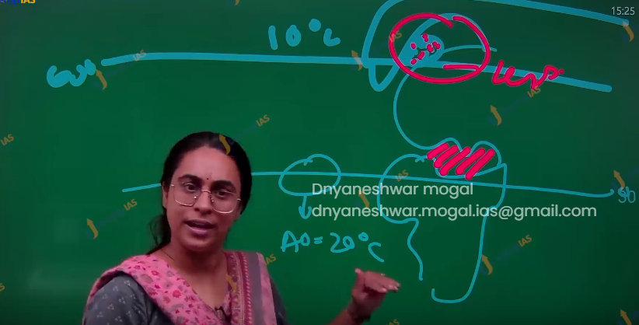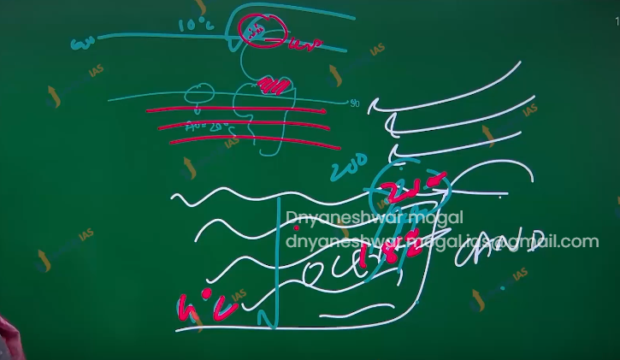

1. Latitude or insulation: Ocean gets heated by the solar energy therefore temperature of surface water decreases from tropics to poles because the amount of insulation decreases the pole wards.

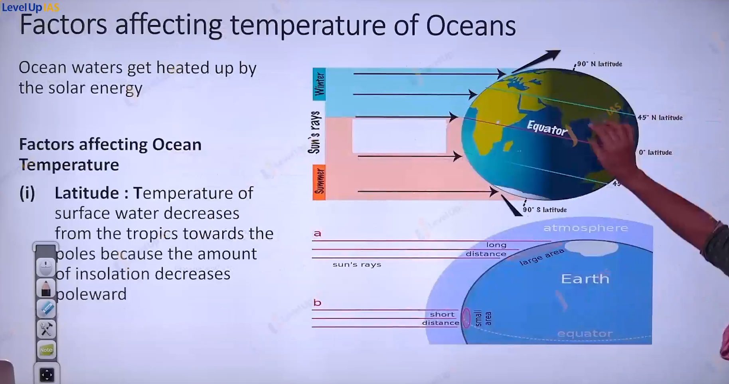

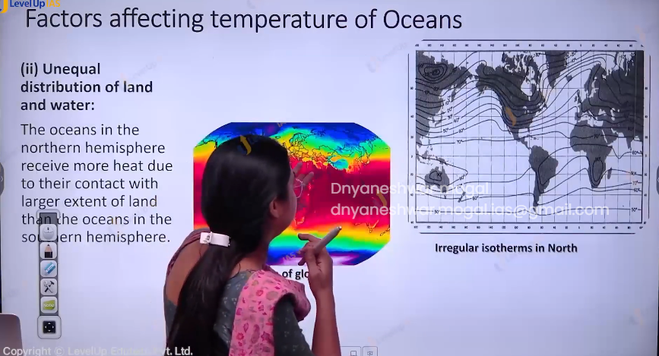

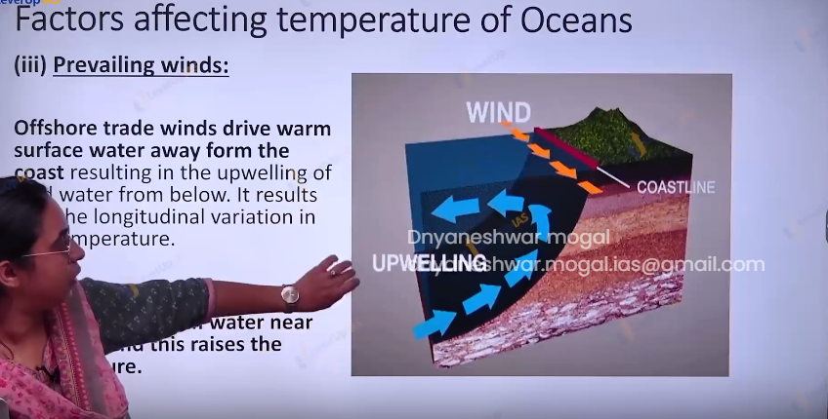

1. Latitude or insulation:
2. Unequal distribution of land and water: the Ocean in the northern hemisphere has more temperature than the ocean that southern hemisphere.
3. Prevailing winds: offshore trade winds dry the warm surface water away from the coast resulting in upwelling of cold water from below. Contrary to this onshore the pill up the warm water near the coast thus raising the ocean temperature.
4. Ocean currents :
   1. Warm ocean currents raised the temperature ex gulf stream raised the temperature of western side of Europe.
   2. Cold ocean currents reduces the temperature of the place. Ex Labrador ocean currents.
5. The condition in the enclosed sea.
   1. Enclosed sea in the lower latitudes records relatively higher temperatures than the open ocean. Where as enclosed sea in the higher latitudes records lower temperatures than the open sea.

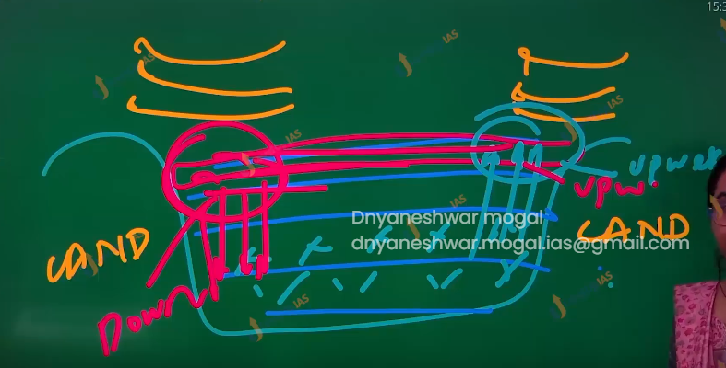

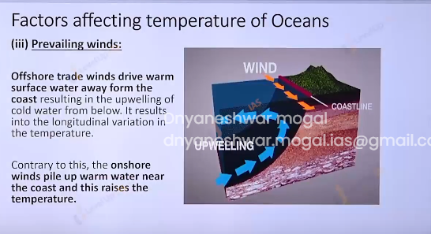

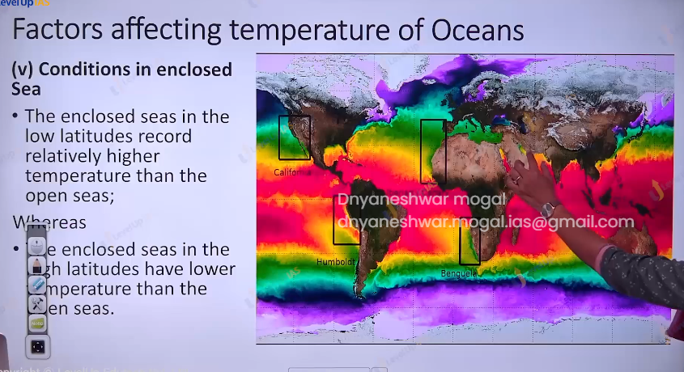

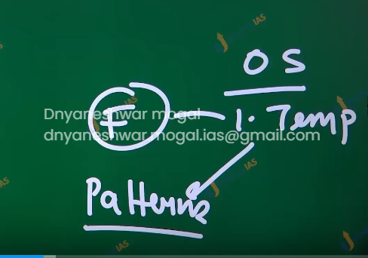

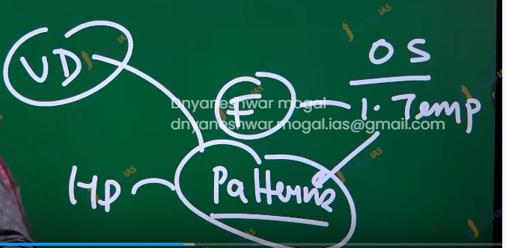

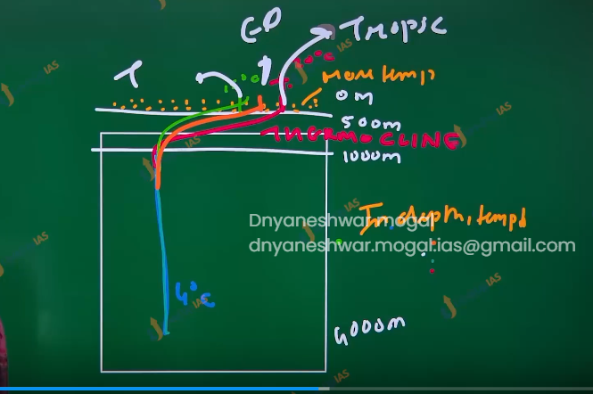

Pattern in the Ocean temperature.

Vertical pattern

1. The vertical profile mentions how temperature decreases with increasing in depth.
2. The maximum temperature of the ocean is on the surface. (generally, in the lower and mid latitudes) because they receive heat from the sun.
3. Heat transmitted to the lower section of the ocean therefore temperature reduces with increasing in depth.
4. But the rate of decrease is not the same throughout. The temperature drops very rapidly between 500m 1000m and thereafter rate of decrease of temperature is slowed down.



1. The first layer:
   1. The top layer of warm oceanic water is 500 m thick.
   2. The temperature is about 20-25 degrees Celsius.
   3. This layer within the tropical region is present throughout but in mid latitude it developed only during the summer.
2. Second layer: (thermocline) extends from 500 to 1000 m.
   1. There is rapid decrease in temperature with increased in the depth.
3. Third layer:
   1. very cold and extents up to deep ocean floor
   2. The temperature is nearly the same 4 degrees Celsius.
4. Artic and Antarctic the surface water temperature can range from 0 -4 degrees Celsius the temperature therefore the temperature change with change in depth is very less hance it can be said only one layer of cold water exist from the surface water to deep ocean floor.

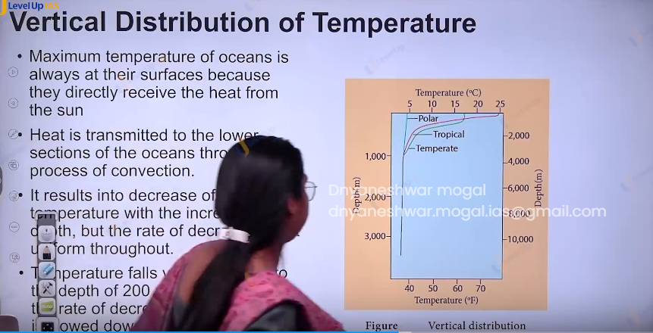

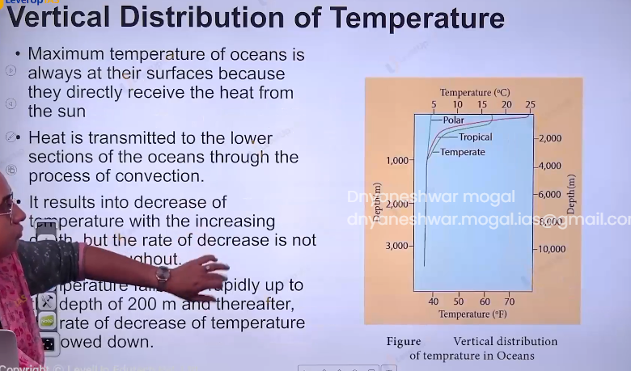

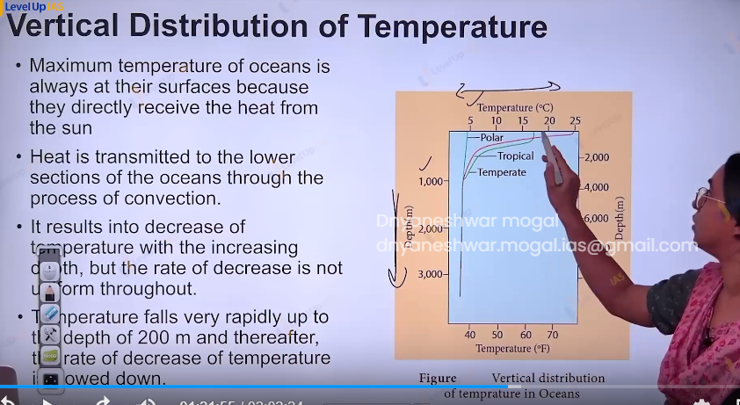

Horizontal distribution of temperature:

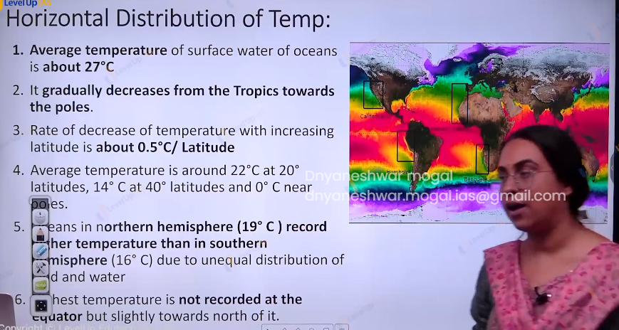

1. The average temperature of ocean is 25 to 27 degrees Celsius it decreases from the tropic to the poles. The rate of decrease with increase in latitude Is .5 degree Celsius per latitude.
2. The temperature in the norther hemisphere is slightly more than southern hemisphere. Due to unequal distribution of land and water.
3. The maximum temperature is not recorded. At the equator but is recorded at the tropical location.

Salinity of Ocean water.

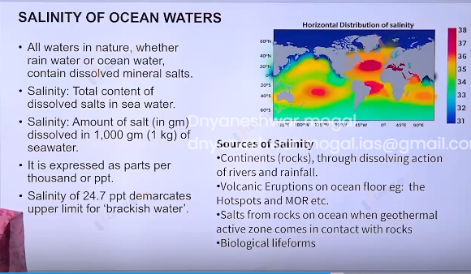

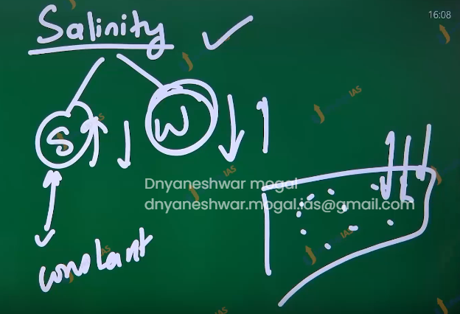

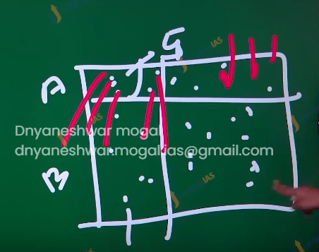

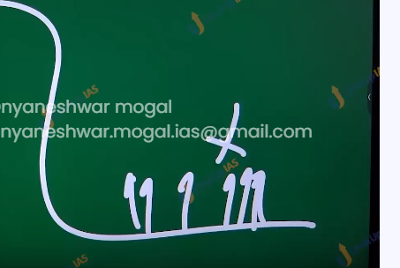

1. Salinity refers to the amount of salt (in grams dissolved in 1000 gm of sea water.) It is expressed as parts per 1000.
2. The sources of salt in the ocean water are.
   1. Continental rock though dissolving the action of river and rainfall.
   2. Volcanic eruptions of ocean floor.
   3. Biological life forms
   4. Salts from the rocks on the ocean floor when high geothermal winds dissolved them.

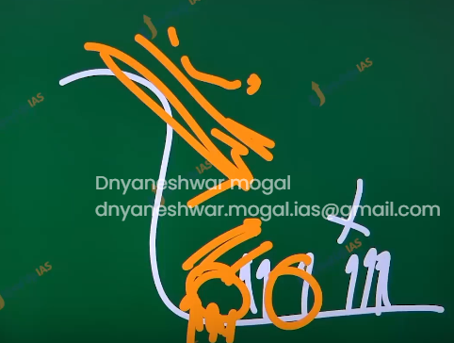

Factor affecting the salinity of ocean water.

1. Evaporation and precipitation:
   1. The salinity in the ocean floor decreases due to precipitation. And increases due to evaporation.
2. Dilution factor:
   1. Salinity is influenced by freshwater flow from the rivers.
   2. Red sea vs Persian Gulf
   3. Persian Gulf has less salinity due to dilution by the water. By u-Fred and anti-grads
   4. The freezing and thawing:
      1. Freezing and thawing of ice also affect the ocean salinity.
      2. Freezing increases salinity due to the process of brine rejection. (Ice is always formed by fresh water and therefore due to freezing of water the salinity of sub-surface water increases.
   5. Thawing of water:
      1. Thawing reduces the salinity:
3. Winds:
   1. Wind influences the salinity of the water by affecting the evaporation.
   2. Winds also transfer the saline water from one place to another.
4. Ocean current:
   1. It contributes to salinity by influencing the temperature.
   2. Warm water dissolves the more salt than cold water therefore they have high salinity.

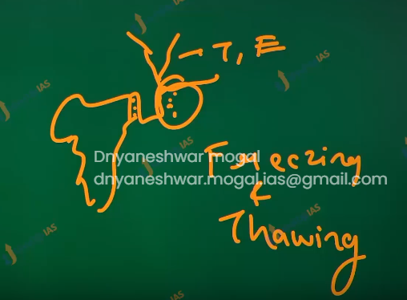

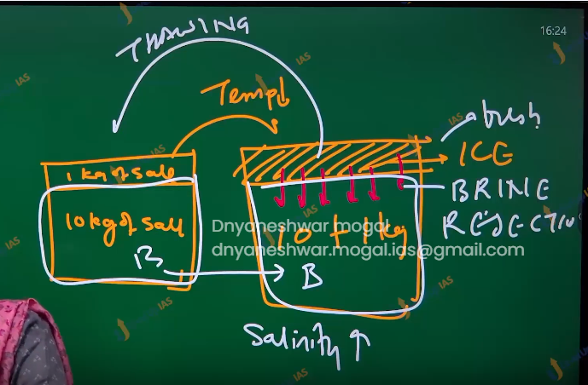

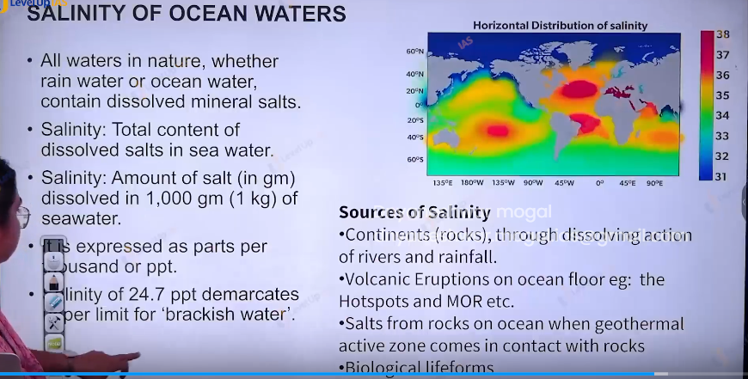

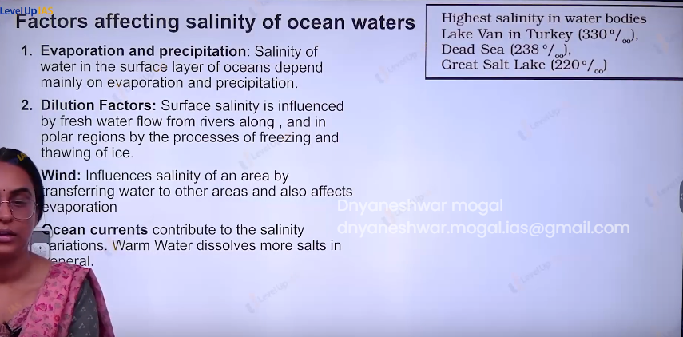

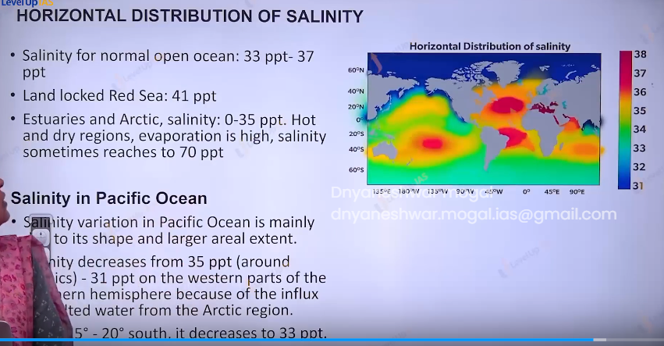

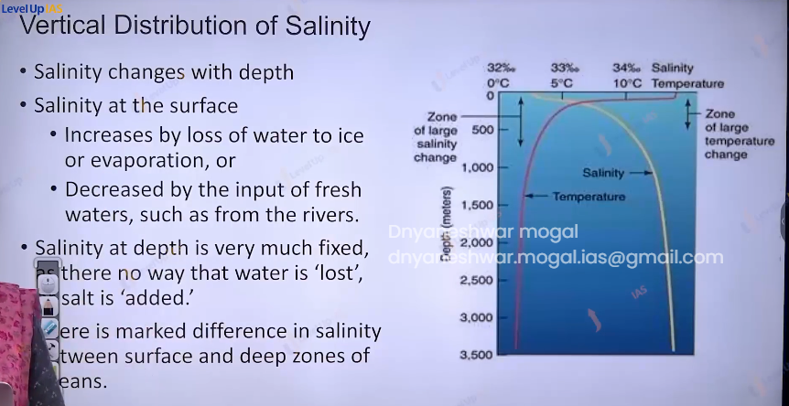

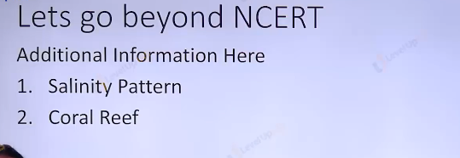

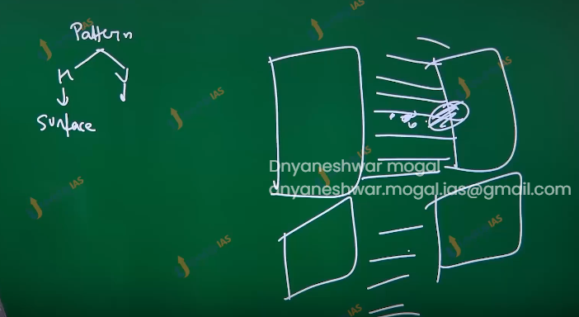

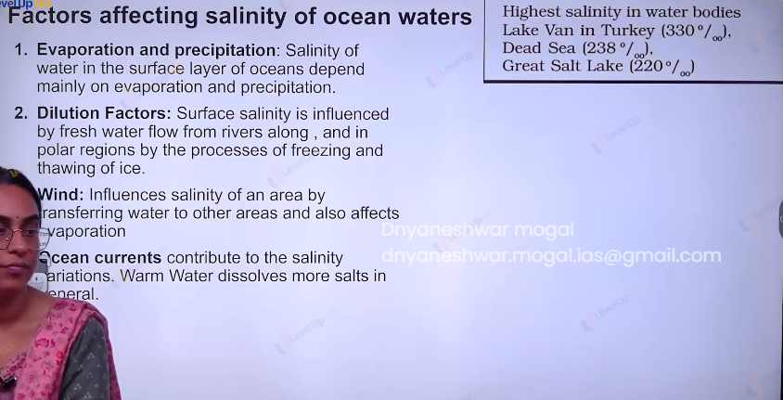

Pattern of salinity

Horizontal and vertical.

Hemispheric contrast:

1. Northern waters are more saline as compared to southern water.
2. The Equator does not have the highest salinity. Highest salinity is recorded along the tropics.
3. In general salinity decreases from tropics to pole because water becomes cooler towards the poles.
4. Warm enclosed and semi enclosed water of tropical area will have higher salinity than the open ocean. Ex red sea, Mediterranean Sea.
5. However the tropical water receiving the freshwater from the river will have less salinity, ex. Persian Gulf vs red sea.
6. A small lake with high evaporation has extremely high salinity.
7. Ex lake warn in turnkey 330 part per 1000, dead sea 238 part per thousand.
8. Ocean waters that receive warm current will have higher salinity. Ex. Norwegian sea.

Cold water with upwelling has lower salinity. Ex. Norwegian Sea

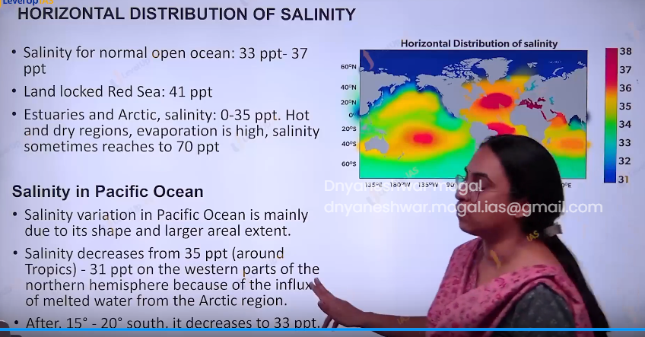

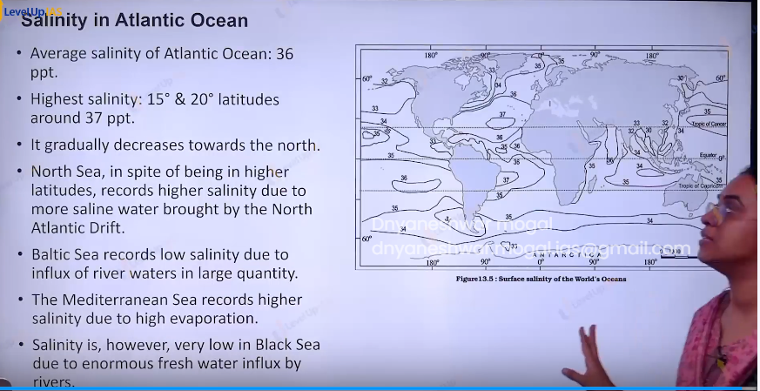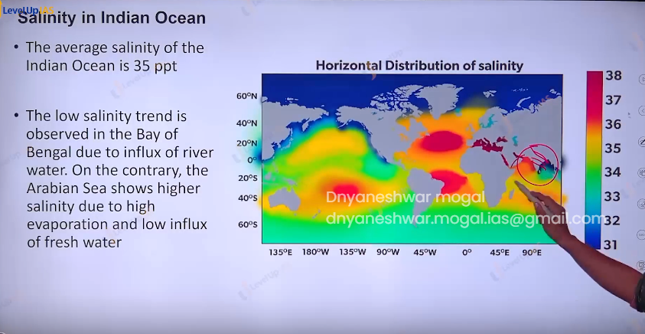

Ocean current video

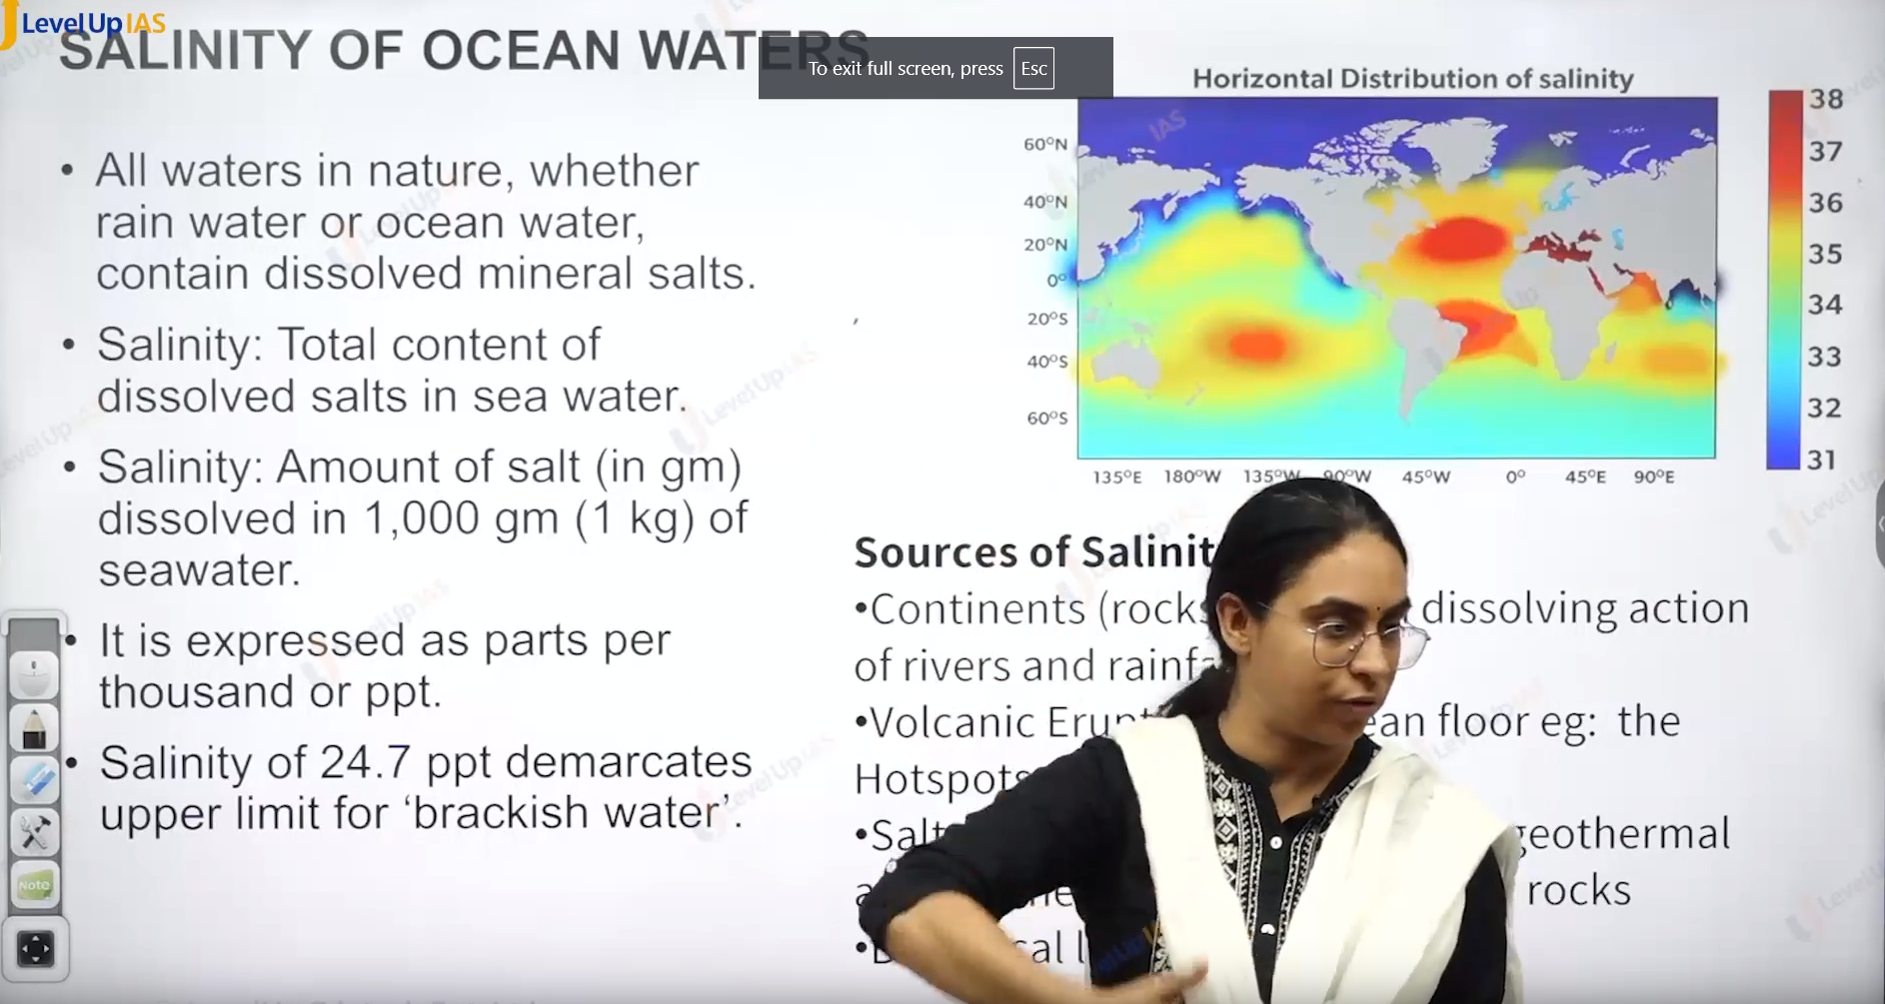

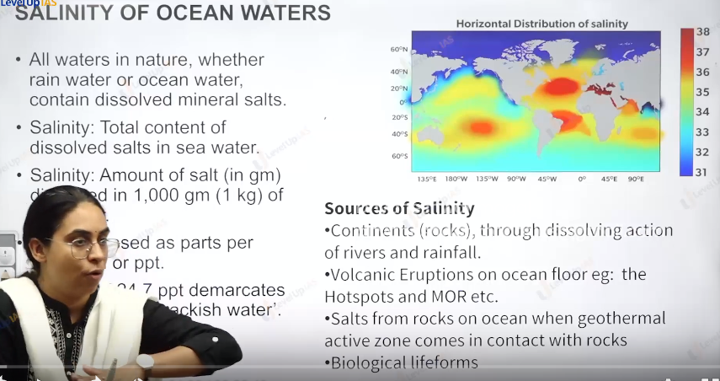

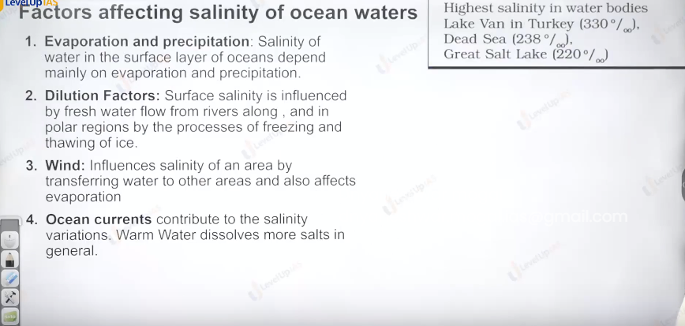

Vertical pattern in the ocean salinity.

1. Salinity changes with the depth. The surface water salinity can change due to many factors. Such as melting of ice delusion of river, loss of water evaporation, freezing of water.
2. Salinity of depth is more or less fixed there is no way drastic change in salt added or removed.
3. Lower saline water rests over higher saline water. Therefore, salinity generally increases with depth.
4. The sharp increase in the salinity is 500m 1000m this zone is called as halocline.
5. The high saline sea water generally sinks below the lower saline waters. This leads to stratification by salinity.

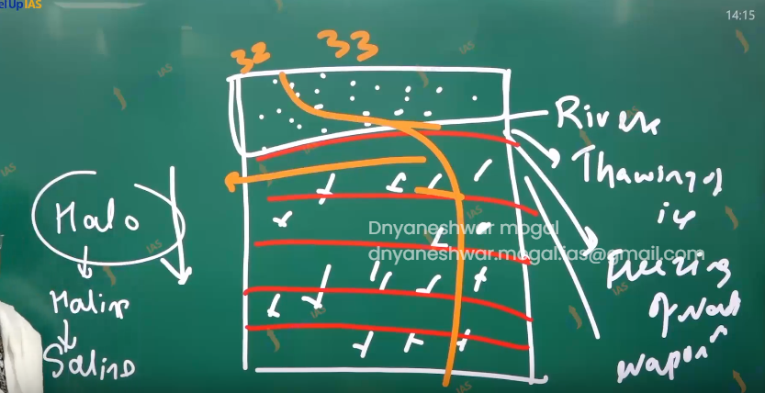

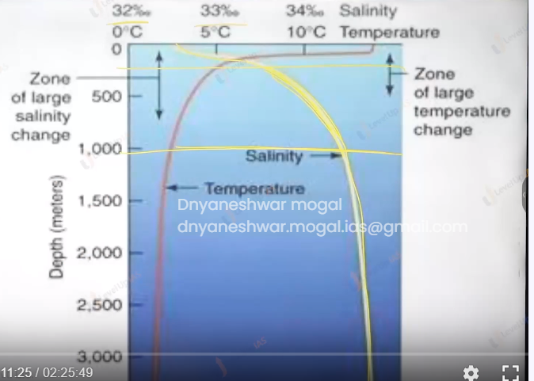

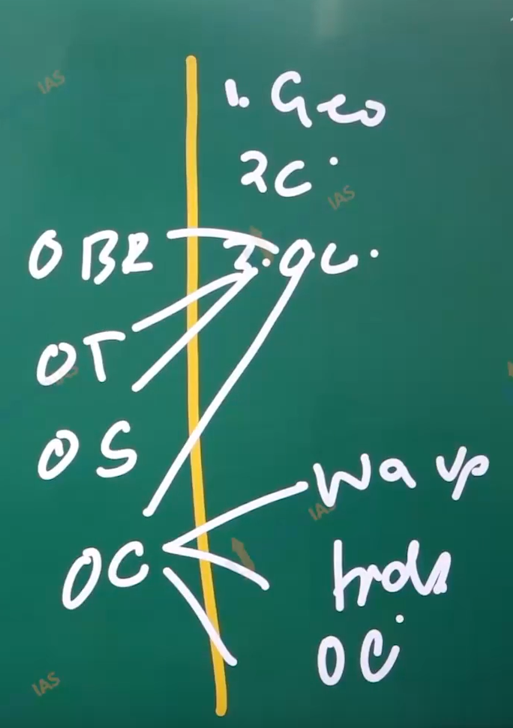

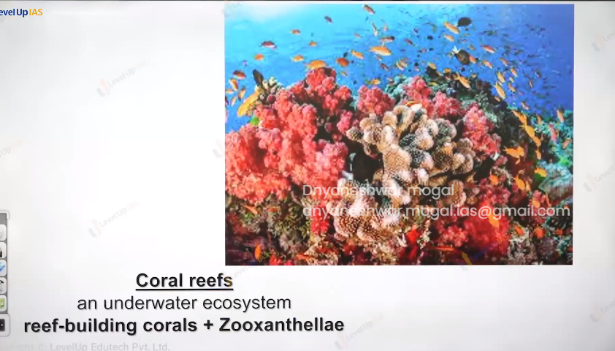

**(25) Ocean Currents**

Coral polyp: (it is an animals)

Coral light: it is skeletal remain of the coral column.

Coral reefs: accumulation of skeletal remain result in the coral reefs in simple term corallite accumulation to formed coral reefs.

1. Coral polyps: lives in symbiotic relationships with algae called zooxanthellae.
2. This symbiotic relationship is very important ecologically as coral polyp provides shelter to zooxanthellae. And zooxanthellae provide the food the coral polyps.
3. When the coral polyps die, the skeletal remain cumulate as coral reefs.
4. Coral reefs are very important ecosystems. They are the rainforest of the ocean. High carbon sequestration (meaning ability to observe) potential.
5. They facilitate rich biodiversity, they are rich fishing grounds and facilitate marine tourisms.

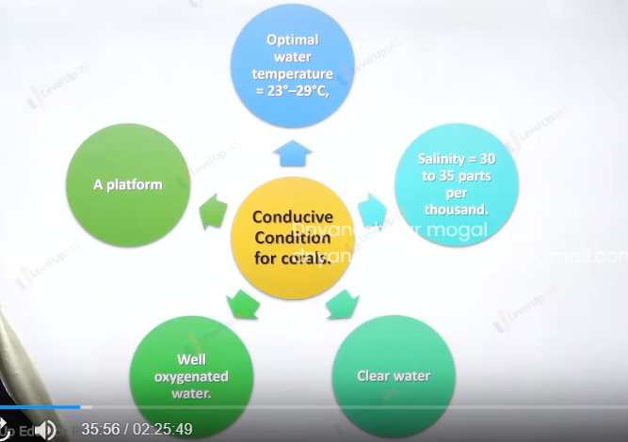

Important condition conducive for coral reefs and coral polyps

1. Sea surface temperatures 23 28 degree Celsius. Therefore, they grow in the tropical ocean.
2. Salinity to be around the 30 35 warts per 1000. They can survive near the river mouth.
3. Clean water (absent of muddy water as they can block the pour of coral reefs they need low nutrients water. They can’t survive the high enrich water.
4. They need a platform which is sallow. Coral polyps cannot swim can’t float and therefore they need the platform for survival.
5. Platform should be shallow with in the photic zone as zooxanthella needs sunlight for photosynthesis.

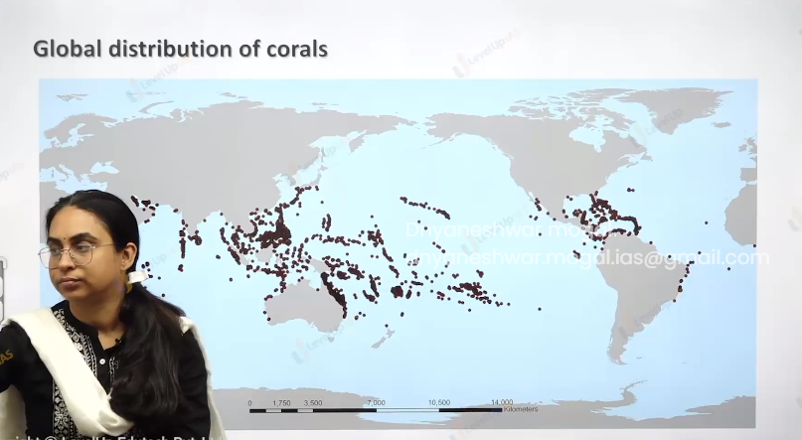

Distribution of coral reefs:

1. They are found along the Gulf of Mexico, Caribbean Sea, western Atlantic Ocean, red sea, Persian gulf, Andaman Nicobar island. There is coral triangle along northeast Australia, Indonesia, Philippines majority of pacific island has coral reefs.

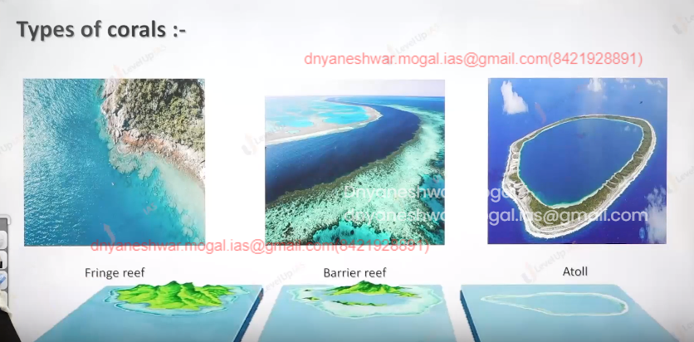

Type of corals reefs:

1. Coral reefs are landform therefore they are remains of coral skeletal.
2. The 3 main types of coral reefs are fringe reef, barrier reef , atoll.

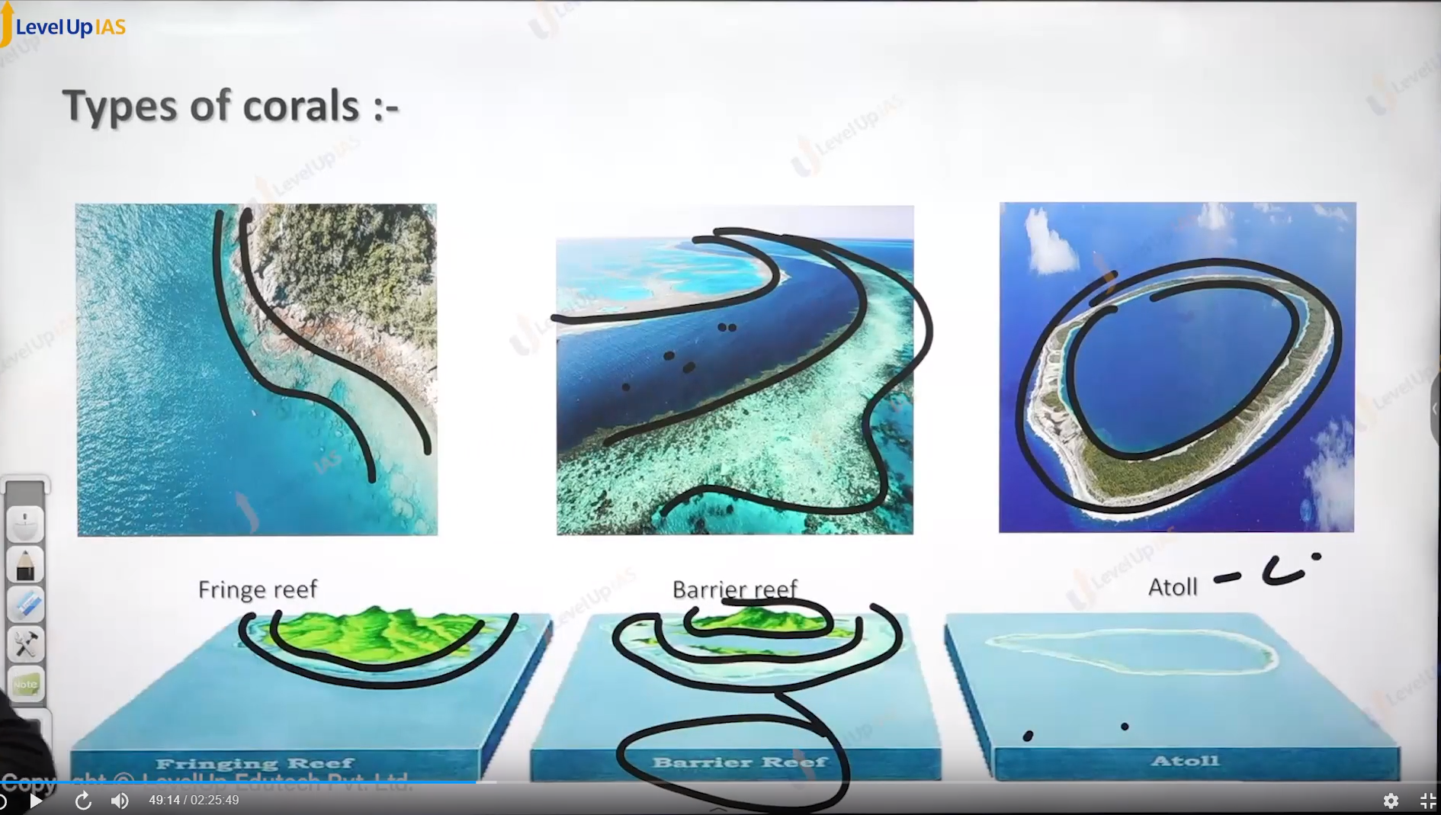

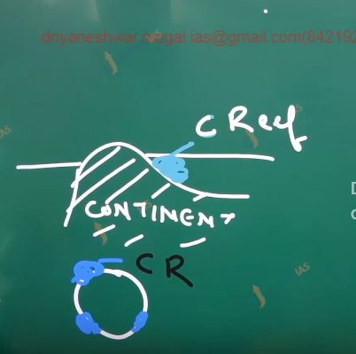

Fringe reefs:

1. They are on the margin of the continent.

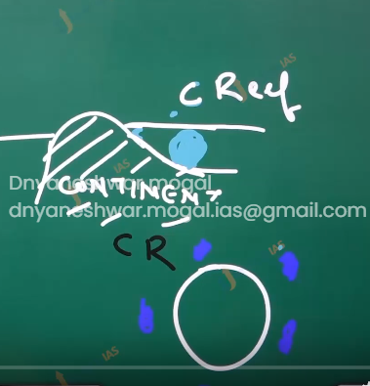

Barrier reefs:

1. They are wide elongated extensive coral reefs, and they are further away from the land

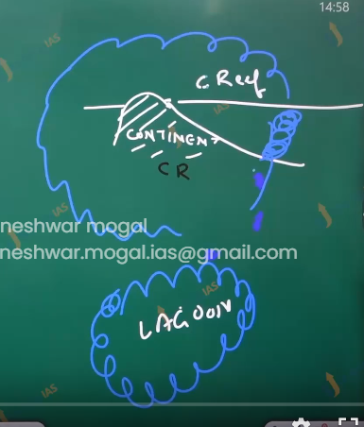

Atoll:

1. They are circular, coral reefs formations, they are very farer from the land and they can enclose shallow lagoon( meaning lake).

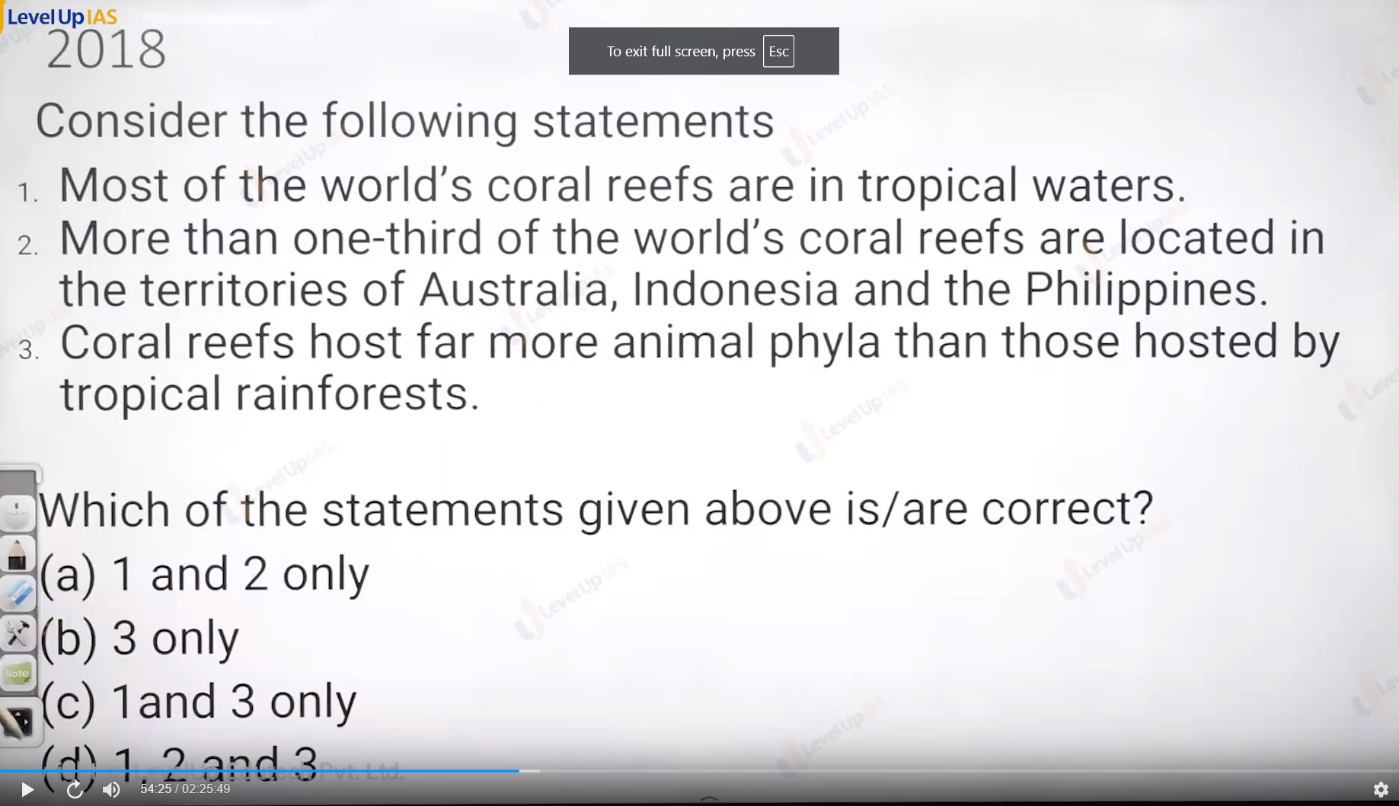

Answer is d.

Most coral reefs are found the tropical water.

1/3 rd. coral reefs are found Indonesia, Philippines and Australia.

Coral reefs store farm more animal phyla than the tropical rainforest.

Bio rock technology:

1. It aims to build the artificial reefs by the applying low voltage electrical current in the ocean to facilitate the dissolved minerals to accumulate on the some platform.
2. The aim of making artificial reefs is to create the habitat for new coral polyps to make symbiotic relationships with zooxanthellae.
3. The technology is used by Zoological survey of India with help of Gujarat Forest department

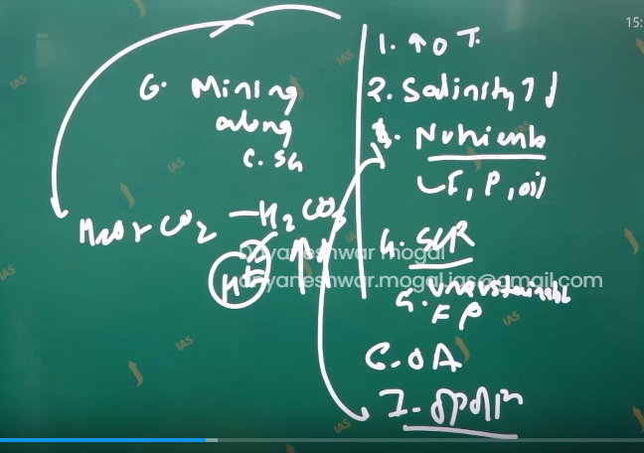

Coral beaching:

1. It refers to the loss of symbiotic relation between coral polyps and zooxanthellae.
2. The coral reefs are very colorful structure but due loss of symbiotic relation the coral loss their color causing the bleaching.

Reason behind the beaching.

1. Global warming / increasing the ocean temperature: symbiotic relation can survive only in the narrow range of temperatures.
2. Ocean acidification: increase in the H positive ions can cause dissolution of carol shell of coral polyps.
3. Changes int the salinity:
4. Increase in the sedimentation due to mining activity.
5. Water pollution due to fertilizer and pesticide, oil spills.
6. Unsustainable fishing practices bottom trolling, cyanide fishing.
7. Increase in the diseases like black band diseases virus attack, virus Shiloh attacks in the Mediterranean Sea.
8. Event like El Nino El Nina
9. Increase stroma and cyclones
10. Ex.
    1. Between 2014-2017 El Nino the great barrier reefs was bleach by 50 %.
    2. between 1997-1998 90% of coral reefs of north Indian ocean was destroyed.



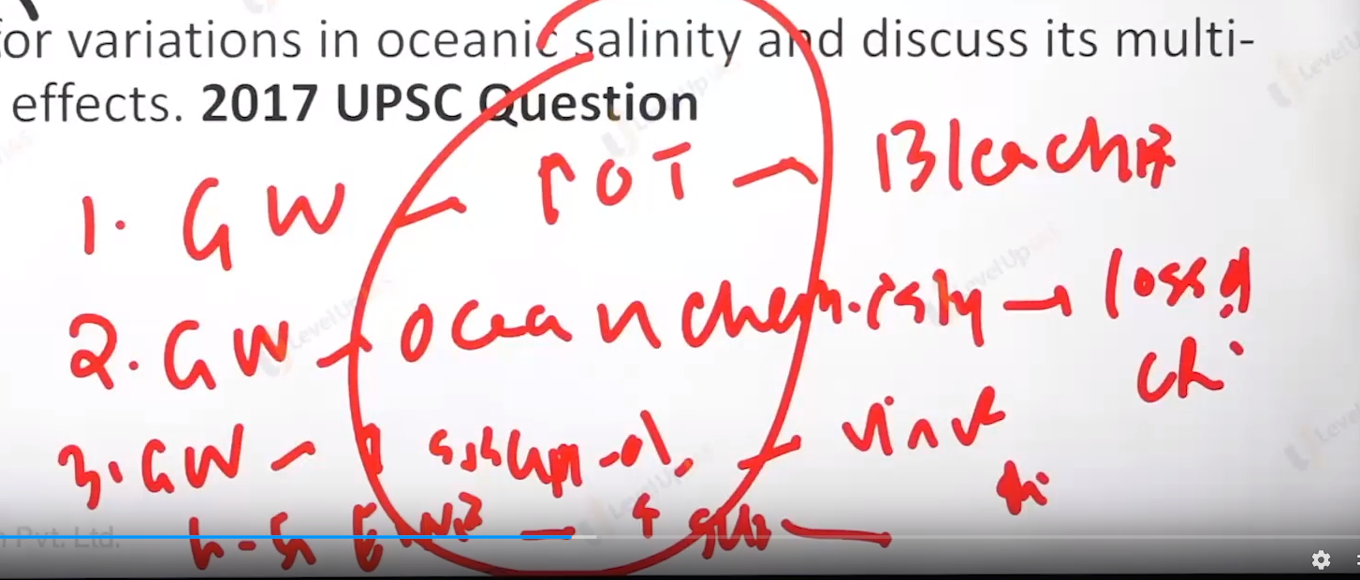

**(25) Ocean Currents**